**Lab 9**

Task 1:

Output:

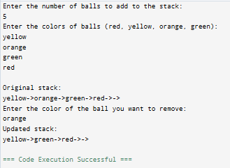

Task 2:

Output:

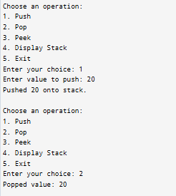

Task 3:

Output:

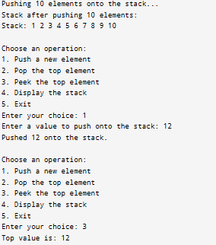

Home Task:

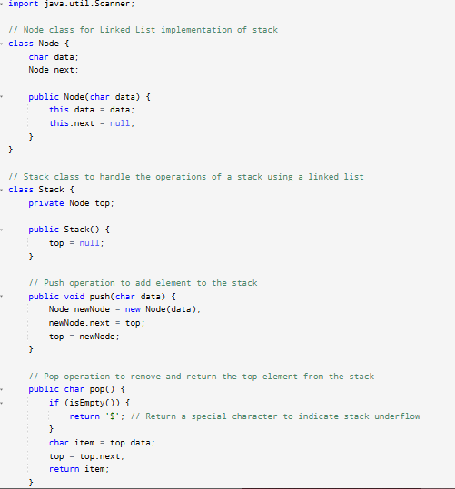

Output:

Home Task

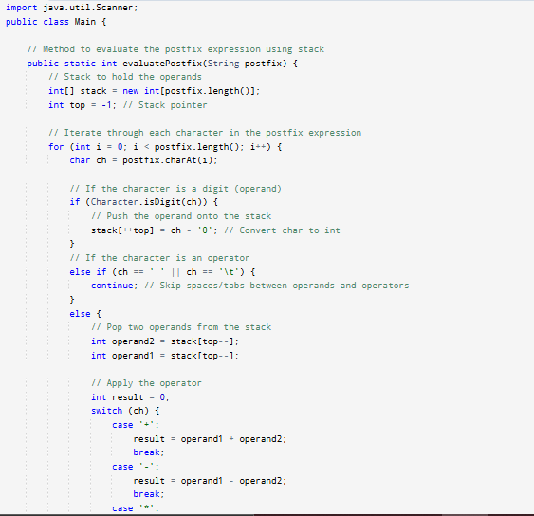

Output:

